
School of Computer Science and Information Systems
Winter Semester 2025-2026
Agile Development Process and Devops Lab

Course faculty- SWETA BHATTACHARYA
Course Code – ISWE406P
Slot- C1+TC1

TOPIC : Git Commands Case Study
Name: DHINESH.S
Reg no: 23MIS0396

Aim
To understand and implement version control operations using Git by performing various case studies such as repository initialization, tracking changes, branching, merging, remote repository handling, undoing mistakes, ignoring files, collaboration, and final project release.

Software / Tools Used
- Visual Studio Code
- Git (Version 2.46.2)
- GitHub
- Operating System: Windows

Case Study 1: New Project Version Control Setup

Objective
To initialize a Git repository and track the initial project files.

Commands Used
mkdir LibraryManagementSystem
cd LibraryManagementSystem
git init
New-Item library.py
git add library.py
git commit -m "Initial commit: Library Management System setup"

Result
A new Git repository was successfully created and the initial version of the project was committed.

Screen Shot:
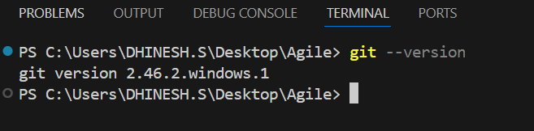

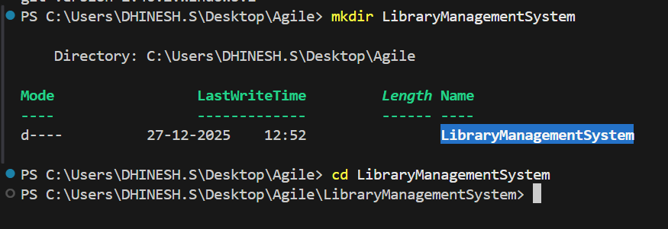

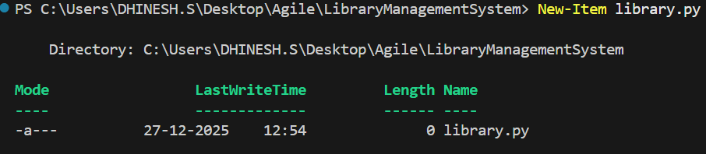

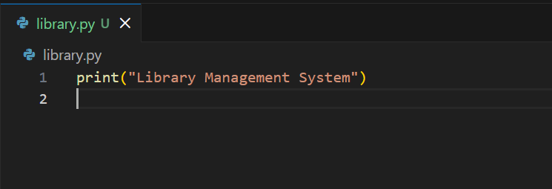

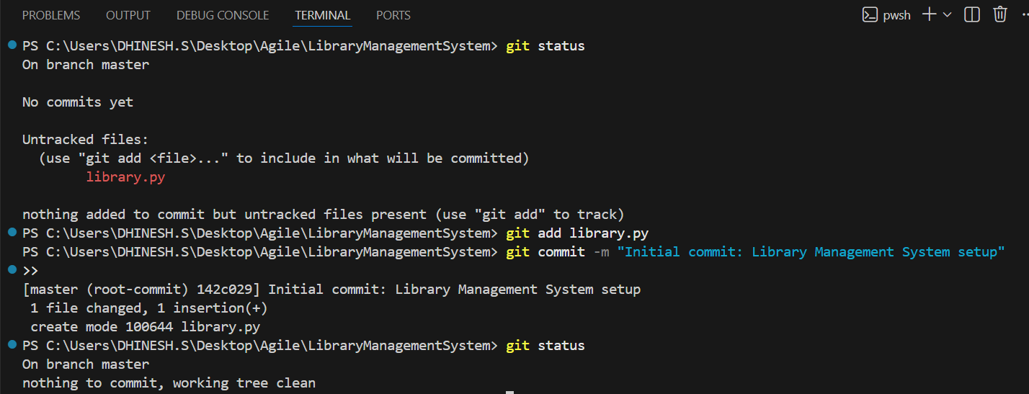

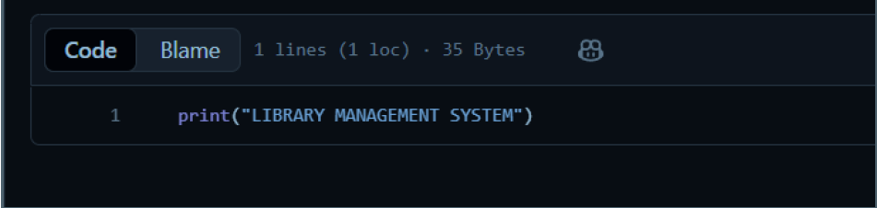

Case Study 2: Tracking Daily Code Changes

Objective
To record and track daily modifications made to the project files.

Commands Used
git diff
git add library.py
git commit -m "Added add_book function"
git log --oneline

Result
File changes were tracked and committed successfully. Commit history was viewed.

Screen Shot:
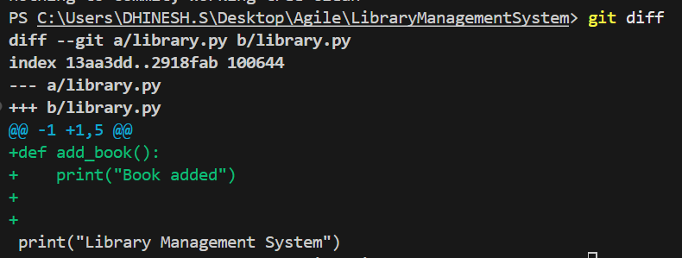

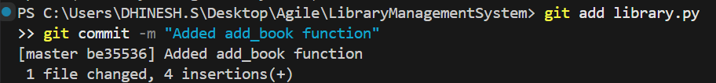

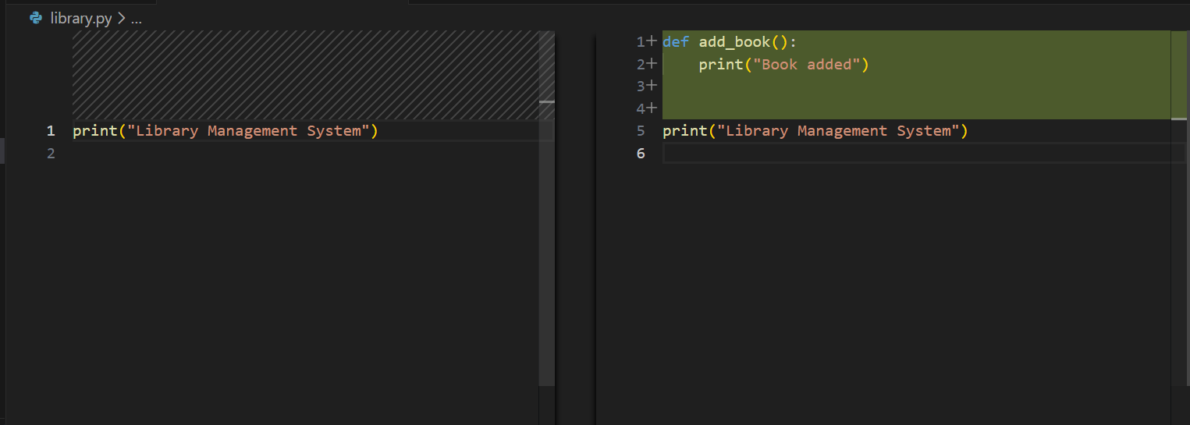

Case Study 3: Feature Development Using Branches

Objective
To develop a new feature without disturbing the main code using branches.

Commands Used
git branch login-feature
git checkout login-feature
New-Item login.py
git add login.py
git commit -m "Added login feature"

Result
A new feature branch was created and login functionality was added.

Screen Shot:
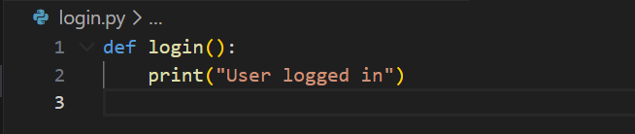
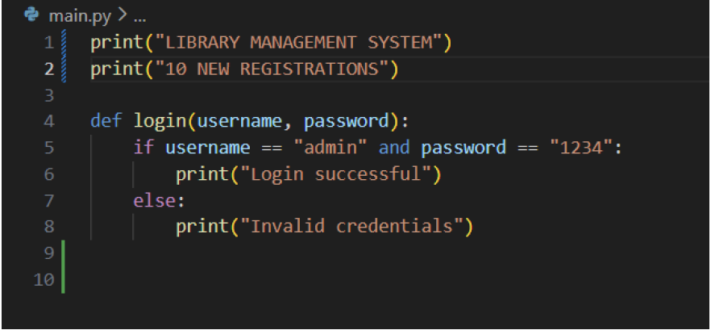

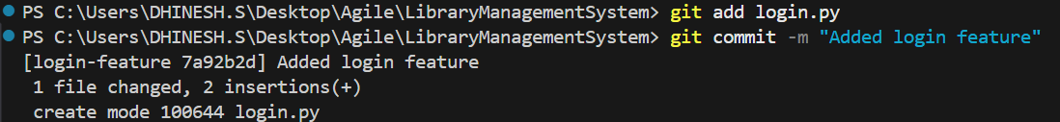

Case Study 4: Merging Feature into Main Code

Objective
To merge the developed feature branch into the main branch.

Commands Used
git checkout master
git merge login-feature
git status

Result
The feature branch was successfully merged into the master branch using fast-forward merge.

Screen Shot:
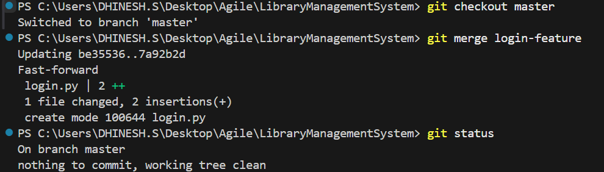
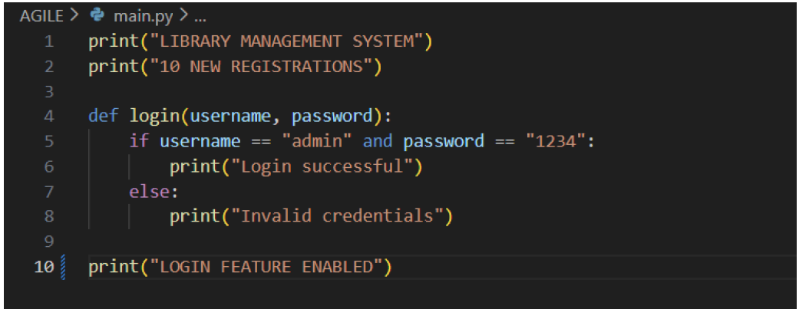

Case Study 5: Working with Remote Repository

Objective
To push the local repository to a remote GitHub repository.

Commands Used
git remote add origin https://github.com/Dhinesh-s2006/Agile_Lab.git
git branch -M master
git push -u origin master

Result
The project was successfully pushed to the remote GitHub repository.

Screen Shot:
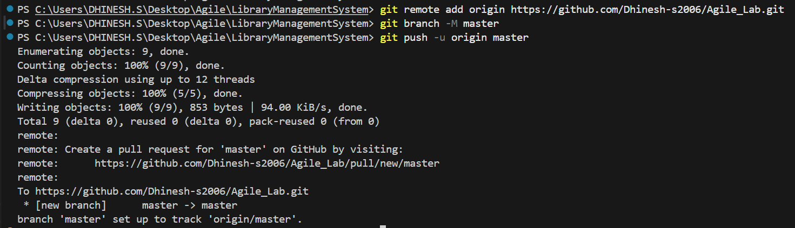
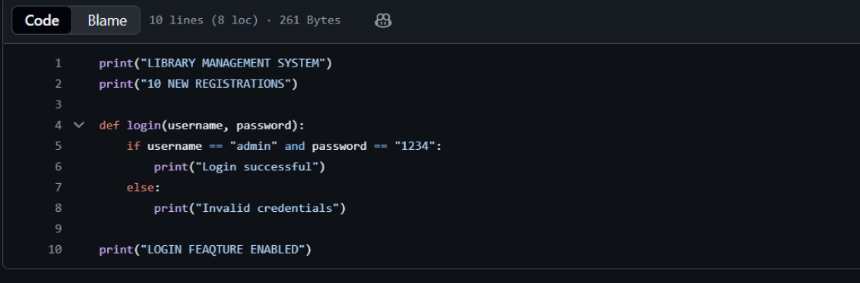

Case Study 6: Undoing Mistakes

Objective
To discard incorrect uncommitted changes made to a file.

Commands Used
git checkout -- library.py

Result
Uncommitted changes were discarded and the file was restored to the last committed state.

Screen Shot:
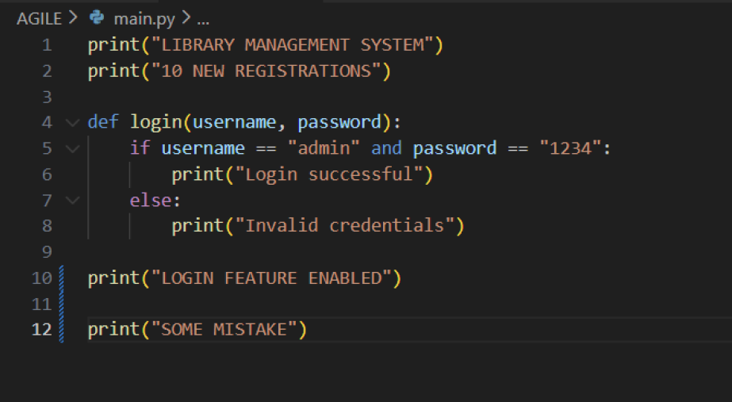
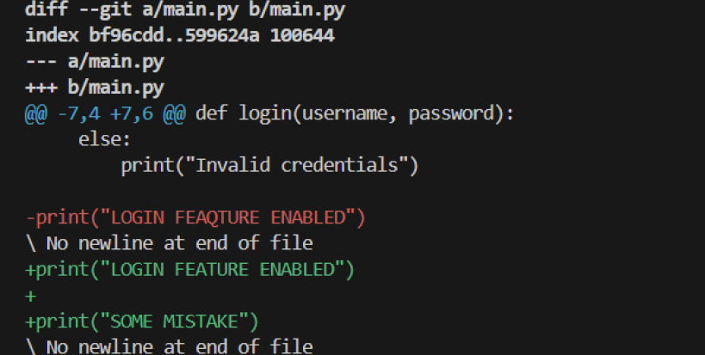

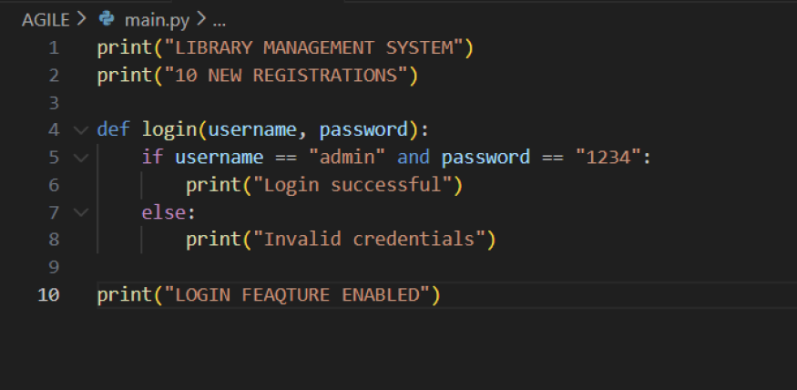

Case Study 7: Handling Merge Conflicts

Objective
To understand and resolve merge conflicts.

Explanation
During this experiment, no merge conflict occurred because different files were modified in different branches. Hence, the merge was completed successfully without conflicts.

Case Study 8: Ignoring Unwanted Files

Objective
To prevent log and temporary files from being tracked by Git.

Commands Used
New-Item .gitignore
git add .gitignore
git commit -m "Added .gitignore file"

.gitignore Content
*.log
*.tmp
__pycache__/
.env
.DS_Store

Result
Specified unwanted files were successfully ignored by Git.

Screen Shot:

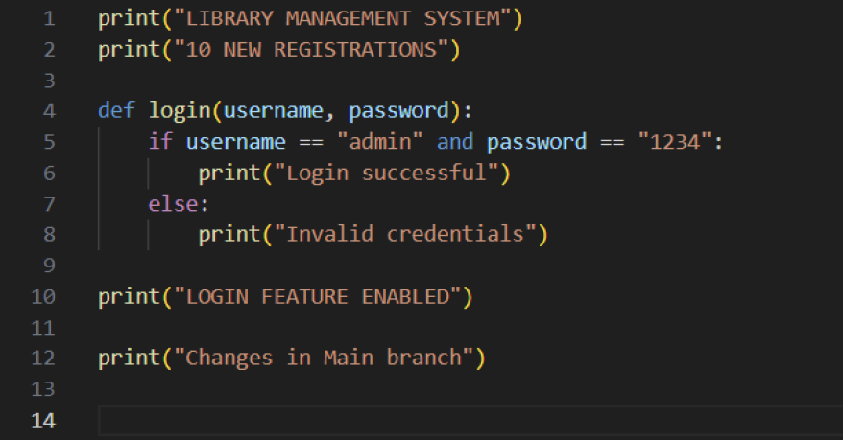
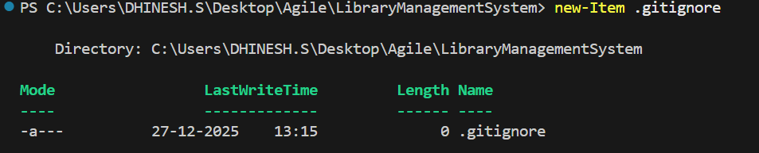

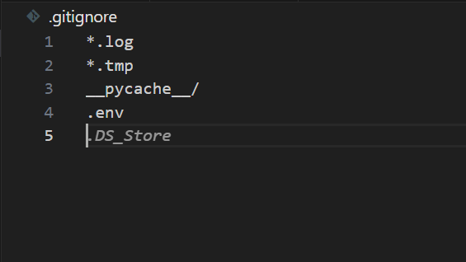

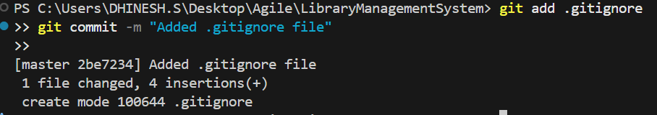

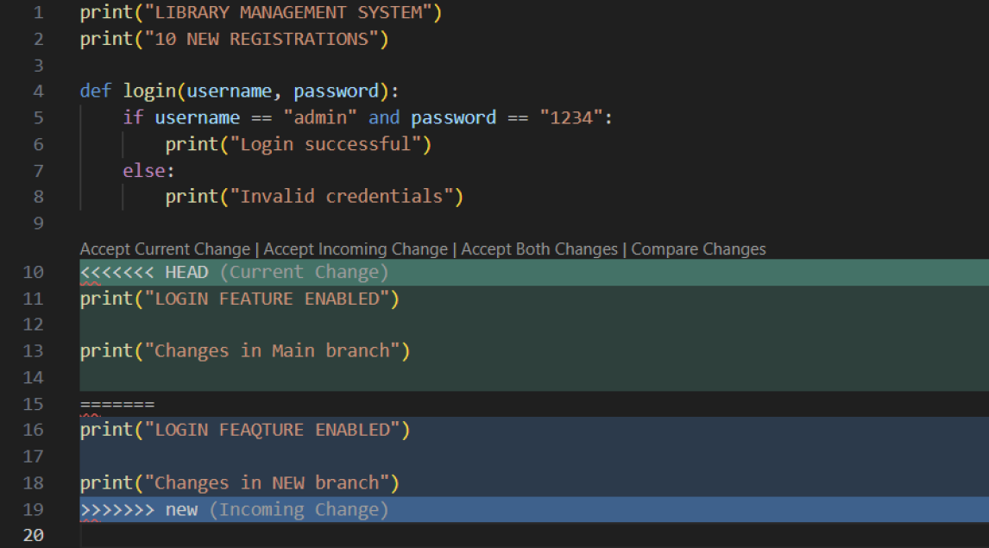

Case Study 9: Collaborating with Team

Objective
To fetch and update changes from a remote repository.

Commands Used
git fetch origin
git pull origin master

Result
Latest changes from the remote repository were fetched and synchronized.

Screen Shot:

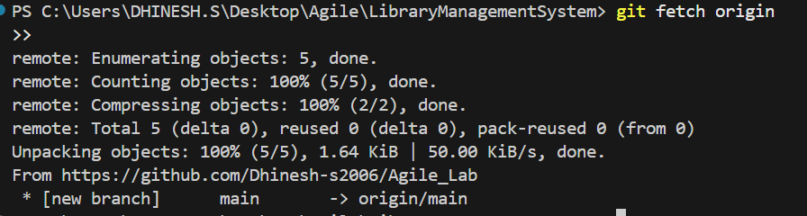

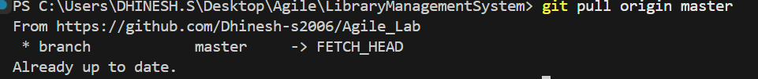

Case Study 10: Final Project Release

Objective
To verify the final state of the project and prepare it for submission.

Commands Used
git log --oneline
git status
git push origin master

Screen Shot:
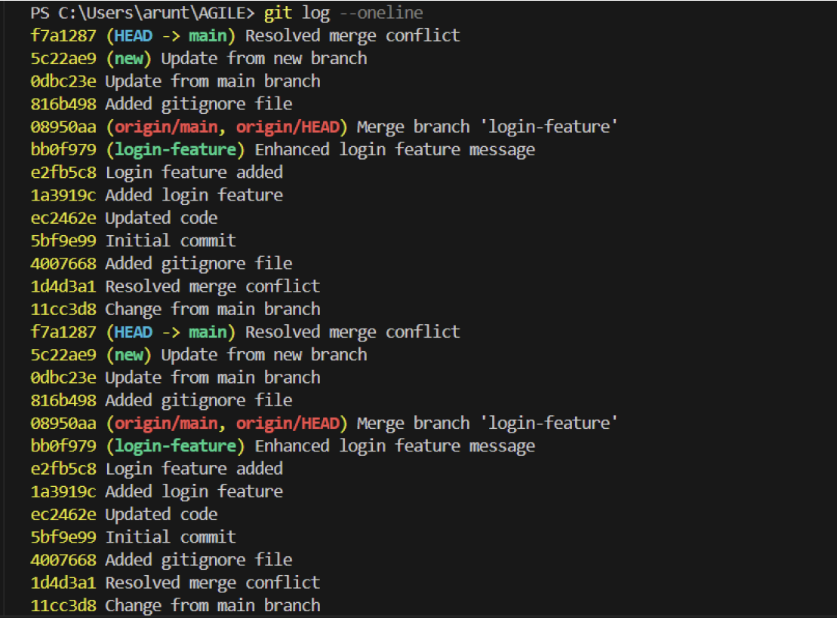

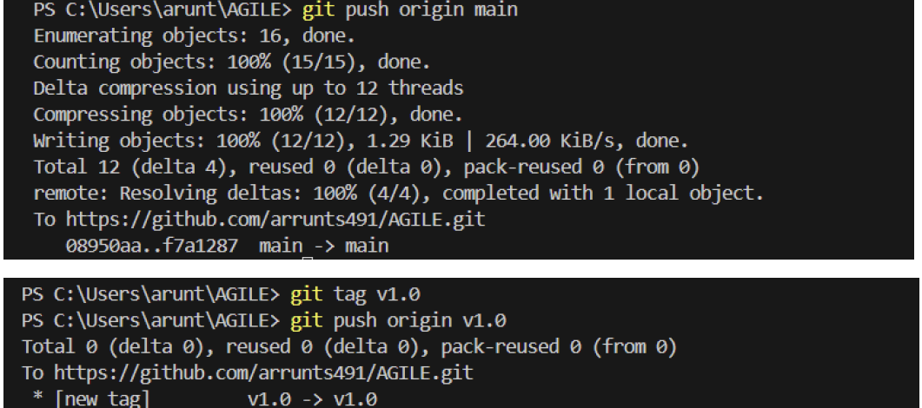

Result
The project was verified, and the final version was successfully pushed to GitHub.

